|  |
| --- |
|  |
| 新概念 3 册 |
| Lesson17 The longest suspension bridge in the world |

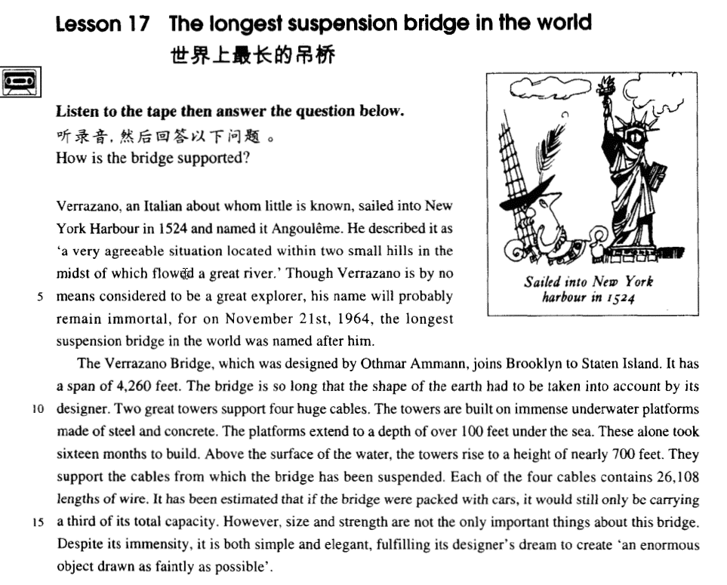

课文

Verrazano, an Italian about whom little is known, sailed into New York Harbour in 1524 and named it Angouleme.

1524年，一位鲜为人知的意大利人维拉萨诺驾船驶进纽约港，并将该港名为安古拉姆。

He described it as 'a very agreeable situation located within two small hills in the midst of which flowed a great river.'

他对该港作了这样的描述：“地理位置十分适宜，位于两座小山的中间，一条大河从中间流过”。

Though Verrazano is by no means considered to be a great explorer, his name will probably remain immortal,

虽然维拉萨诺绝对算不上一个伟大的探险家，但他的名字将流芳百世，

for on November 21st, 1964, the longest suspension bridge in the world was named after him.

因为1964年11月21日建成的一座世界上最长的吊桥是以他的名字命名。

The Verrazano Bridge, which was designed by Othmar Ammann, joins Brooklyn to Staten Island.

维拉萨诺大桥由奥斯马.阿曼设计，连结着布鲁克林与斯塔顿岛，

It has a span of 4,260 feet.

桥长4,260英尺。

The bridge is so long that the shape of the earth had to be taken into account by its designer.

由于桥身太长，设计者不得不考虑了地表的形状。

Two great towers support four huge cables.

两座巨塔支撑着4根粗大的钢缆。

The towers are built on immense underwater platforms made of steel and concrete.

塔身建在巨大的水下钢盘混凝土平台上。

The platforms extend to a depth of over 100 feet under the sea.

平台深入海底100英尺。

These alone took 16 months to build.

仅这两座塔就花了16个月才建成。

Above the surface of the water, the towers rise to a height of nearly 700 feet.

塔身高出水面将近700英尺。

They support the cables from which the bridge has been suspended.

高塔支撑着钢缆，而钢缆又悬吊着大桥，

Each of the four cables contains 26,108 lengths of wire.

4根钢缆中的每根由26，108股钢绳组成。

It has been estimated that if the bridge were packed with cars, it would still only be carrying 1/3 of its total capacity.

据估计，若桥上摆满了汽车，也只不过是桥的总承载力的1/3。

However, size and strength are not the only important things about this bridge.

然而，这座桥重要特点不仅是它的规模与强度。

Despite its immensity, it is both simple and elegant, fulfilling its designer's dream to creat 'an enormous object drawn as faintly as possible'.

尽管此桥很大，但它的结构简单，造型优美，实现了设计者企图创造一个“尽量用细线条勾画出一个庞然大物”的梦想。

词汇讲解

* **suspension [sə'spenʃn]** n. 悬挂；暂停；（因违规而）停职，停课

**suspension bridge** 吊桥

* the **suspension** of the peace talks 暂停
* Annie got a 3-day **suspension** for smoking in school. 停课

**suspend sth. from sth.** 把…挂在…

* A lamp was **suspended** **from** the ceiling.
* Oddly shaped forms that are **suspended** **from** the ceiling and move in response to a gust of wind are quite familiar to everybody.

**hang from sth.** 挂在…

* In the corner of the room was a large lamp, **hanging from** the ceiling.
* The ferry service has been **suspended for** the day because of bad weather.
* A tiny asterisk conducted me to a footnote at the bottom of the page. It said: 'This service has **been suspended**.'
* The policeman **was suspended** while the complaint was investigated.
* Dave **was suspended from** school **for** a week.
* **situation** [sɪtʃu'eɪʃn] n. 地点，位置；情况，处境

**situation/location** 表“地点，位置”可替换

* a beautiful situation / location overlooking the valley (地点，位置)
* His apartment is in a really good situation / location. (地点，位置)
* She found herself in an embarrassing **situation**.处境
* This can give rise to curious **situations**, as it did in the case of Alfred Bloggs who worked as a dustman for the Ellesmere Corporation.
* She tried to explain the **situation**, saying 'It's only me', but it was too late.

**situate** /**locate**/ **site** vt.位于

* The monastery is **situated / located / sited** in a valley.

**stand**（站） **sit**（坐） **lie**（躺）**三个词都是主动形式**

* Near the railway station stood a hotel.
* The house **sits** on top of a hill
* The town **lies** on the coast.
* **immortal [ɪ'mɔ:tl]** adj. 永生的；流芳百世的
* Plato believed that the soul is **immortal**. 永生的
* the **immortal** Shakespeare. 流芳百世的
* Emily Bronte's **immortal** love story. 不朽的
* His telescopic observations are justly **immortal**; 不朽的

**mortal** ***adj.*** 凡人的；致死的；终有一死的；不共戴天的

* All human beings are **mortal**.

**a mortal wound** 致命的外伤

* He **became mortally ill** （得了致命的疾病）a few months before we had planned to go and, when he knew that he was dying, he made me promise to go on my own.

**immoral** ***adj.*** 不道德的；邪恶的；淫荡的

* It's immoral to steal.

**moral** ***adj.*** 道德的；精神上的；品性端正的

* the decline of moral standards(道德标准)

**moral support / obligation** 道义支持/责任

* I know only that what is moral is what you feel good after and what is immoral is what you feel bad after. ― Ernest Hemingway
* **span** [spæn] n. 跨度；一段时间
* The arch has a **span** of 60 meters. 距离跨度
* I worked with him over a **span** of six years. 时间跨度
* The project must be completed within a specific time **span**. 时间跨度
* Small children have a short attention **span**. 时间跨度

**wingspan** ***n.*** 翼展；翼幅

* a bird with a two-foot **wingspan**

**lifespan *n.*** 寿命；预期生命期限；预期使用期限

* Men have a shorter **lifespan** than women.
* A TV set has an average **lifespan** of 11 years.
* **concrete** ['kɒŋkri:t] n. 混凝土
* modern buildings made of **concrete**.
* The towers are built on immense underwater platforms made of steel and concrete.

**a concrete floor / wall / building** 护凝土的地板/墙/建筑

**concrete evidence / proposals / examples** 具体的证据/建议/例子

* Even if one didn't know from **concrete examples** (the 1936 Olympic Games, for instance) that international sporting contests lead to orgies of hatred, one could deduce it from general principles.

**abstract** ***adj.*** 抽象的；深奥的

* Beauty itself is **abstract**.
* There are rare instances when justice almost ceases to be an **abstract** concept.
* **capacity** [kə'pæsəti] n. 容量，承受量；能力

**capacity of …** 容量

* The jug has **a capacity of** half a liter.
* The stadium has a seating **capacity of 50,000**.
* The new truck has **a loading capacity of 2.5 tons**.

**capacity for …** 做某事的能力

* He has a great **capacity for** work.
* My **capacity for** mathematics is negligible.

**capacity to do …** 做某事的能力

* her **capacity to read** and write
* We would lay less stress on 'facts and figures' and more on a good memory, on applied psychology, and on the **capacity** of a man **to** get along with his fellow-citizens.

**ability to do …**做某事的能力

* Our **ability to think** and speak makes us different from other animals.

**capability to do …** 做某事的能力

**capability of …** 做某事的能力

* You have the **capability to do / of doing** this job well.

**powers of …** 做某事的能力

* Teachers have the responsibility to develop students' **powers of** critical thinking.
* If parents were prepared for this adolescent reaction, and realized that it was a sign that the child was growing up and developing valuable **powers of** observation and independent judgment, they would not be so hurt, and therefore would not drive the child into opposition by resenting and resisting it.

**aptitude for …** (先天)做某事的能力

* At an early age Susan showed an **aptitude for** languages.

课文讲解

# Verrazano, *an Italian about whom little is known*, sailed into New York Harbour in 1524 and named it Angouleme.

知识点（一）

**表示“大概了解某事”：**

**know of / about** **…**

**hear** **of / about** **…**

**learn** **of / about** **…**

* I don't know him personally, though I **know of / about** him.
* George was not too upset by his experience because the lady who owns the sweet shop **heard about** his troubles and rewarded him with a large box of chocolates.

知识点（二）

**语法：在正式书面语中，若关系代词做介词宾语，需将介词置于关系代词之前，非正式文体无此限制**。

* Verrazano, an Italian ***about***whom little **is known**, sailed into New York Harbour in 1524 and named it Angouleme.
* They support the cables ***from***which the bridge has **been suspended**.
* （正式）This is the house ***in***which I lived for 10 years.
* （非正式）This is the house which I **lived *in***for 10 years.
* （正式）I have read the poem *of* which she is **speaking**.
* （非正式）I have read the poem which she is speaking *of*.

知识点（三）

**about whom / which little is known** 鲜为人知的

* **造句**：Mary 和她的丈夫 Dimitri 住在 Perachora，一个鲜为人知的希腊小村庄。
* Mary and her husband Dimitri lived in Perachora, a tiny Greek village about which little is known.
* **造句**：张继，一位鲜为人知的中国诗人，曾经写过一首著名的诗歌，《枫桥夜泊》(“Mooring by Maple Bridge at Night”)。
* Zhang Ji, a Chinese poet about whom little is known, once wrote a famous poem “Mooring by Maple Bridge at Night”.

知识点（四）

**name sb. …** 给某人起名字

* We **named** **our daughter** Sarah.

**name … after …** 按照后面的事物给前面起名字

* He was **named** **after** his father.
* Tasmania was **named after** its discoverer, A. J. Tasman.
* Though Verrazano is by no means considered to be a great explorer, his name will probably remain immortal, for on November 21st, 1964, the longest suspension bridge in the world was **named after** him.

# He described it as *'a very agreeable situation located within two small hills in the midst of which flowed a great river*.'

知识点（一）

**describe … as (being) …** 把…描述成…

* The man **was** **described as (being)** tall and dark, and aged about 20.
* Jim **was described** by his colleagues **as (being)** 'unusual'.
* The old lady thought he was a fussy creature, but since the porter agreed with him, she rang up her daughter and asked for her help in what she **described as** a little spot of bother.
* Those who never have to move house become indiscriminate collectors of what can only be **described as** clutter.
* At the time, however, she was not only the largest ship that had ever been built, but **was regarded as *unsinkable*,** for she had sixteen watertight compartments.

知识点（二）

**agreeable** adj. pleasant ***adj.*** 令人愉快的；适合的；和蔼可亲的

* We spent a most agreeable evening by the river.

知识点（三）

*located* 可以替换层 situated，课文是为了避免同根词重复

He described it as 'a very agreeable situation *located* within two small hills in the midst of which flowed a great river.'

知识点（四）

**midst: middle**

* in the **midst** of the crowd

**whilst: while**

* The days were hot **whilst** we were on vacation.

**amongst: among**

* There is always hope that in its labyrinth of musty, dark, disordered rooms a real rarity will be found **amongst** the piles of assorted junk that litter the floors.

知识点（五）

完全倒桩：In the midst of two small hills *flowed* a great river.

简单句：A great river *flowed* in the midst of two small hills.

**语法复习：全部倒装**，**把全部谓语置于主语之前。**

**1、 表示位置或次序的状语置于句首，只要满足两个条件，要用全部倒装。**

①主语不是代词。②谓语动词不是及物动词。

* A subway station *stands* in front of a huge shopping mall. 正常语序
* In front of a huge shopping mall *stands* a subway station. 全部倒装
* **造句**：这家饭馆的位置非常方便，位于一家大型购物中心的正中央，在购物中心前有一座地铁站。
* The restaurant is in a very convenient situation. It is located right in the center of a huge shopping mall. A subway station stands in front of the shopping mall. （简单句）
* The restaurant is in a very convenient situation located right in the center of a huge shopping mall in front of which stands a subway station.（全部倒桩）

# Though Verrazano is by no means *considered to be* a great explorer, his name will probably remain immortal, for *on November 21st, 1964*, the longest suspension bridge in the world was named after him.

知识点（一）

**语法：表示“一点也不”“绝不”置于句首部分倒装**

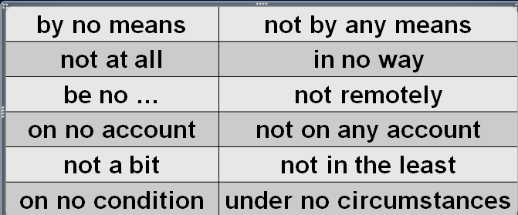

* She is **by no means** pretty.
* She's **not** a bad kid, **by any means**.
* **By no means can**theory be separated from practice. （倒转）
* She's **not at all** happy about the current situation.
* This will **in no way** influence our original decision.
* I **am no** expert.
* That girl **is no** fool.
* Larry **is no** friend of mine.
* His arguments are **not remotely** convincing.
* **On no account** *must*you disturb me when I'm working. Do not on any account leave the prisoner unguarded. （倒转）
* I tried to convince them, but they were**n't in the least interested.**
* "Was she annoyed?" "**Not a bit**! She was delighted."
* **On no condition *should*** untrained personnel use the equipment. （倒转）
* **Under no circumstances *will*** we agree to splitting up the company. （倒转）

知识点（二）

**consider … to be …** 把…认为是

* We **consider this (to be)** very important.
* He **was considered (to be)** a weak leader. will remain immortal

知识点（三）

**The name of** Lei Feng **will remain immortal.** 名字将会流芳百世

* The tragic sinking of this great liner **will always be remembered,** for she went down on her first voyage with heavy loss of life.

**will always be remembered**

* The tragic missing of the Malaysian airliner will always be remembered.

知识点（四）

**表示：“以…命名”**

**sth. be named after sb.**

**sth. be named for sb.**

**sth. be named in honor of sb.**

* The college is named **after / for / in honor of** George Washington.

# The Verrazano Bridge, which was designed by Othmar Ammann, joins Brooklyn to Staten Island.

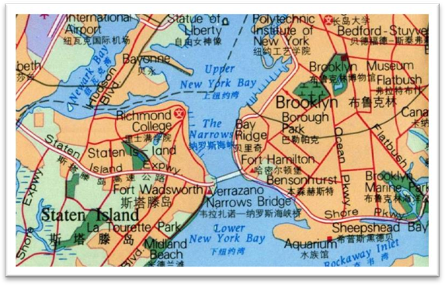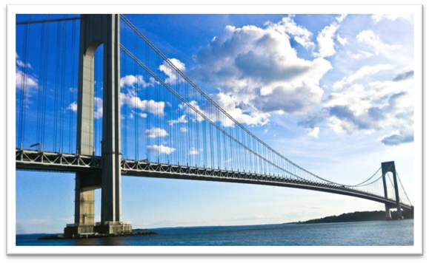

**join A to B** 把A连接到B

* The island is **joined** **to** the mainland by a bridge.

**表达“把A连接到B”：**

**link A with / to B**

**connect A with / to B**

* The Great St Bernard Pass **connects** Switzerland **to** Italy.

**表达“把A和B联系起来”：**

**link A with / to B**

**connect A with / to B**

**associate A with B**

**relate A to B**

* **课后习题讲解：**

10 The Verrazano Bridge ___C___ Brooklyn with Staten Island. (1.8)

(a)attaches (b)unifies (c) links (d) relates

# It has a span of 4,260 feet.

**have a span of…** 有…长

* The arch **has a span of 60 meters**.

**介词of引出数量值**

* It has a span **of** 4,260 feet.
* at the age **of** 52
* an increase **of** 3%
* a revenue **of** $3.4 billion
* a pay raise **of** 4 percent
* a salary **of** 30,000 dollars a year
* The platforms extend to a depth **of** over 100 feet under the sea.
* Above the surface of the water, the towers rise to a height **of** nearly 700 feet.

# The bridge is so long that the shape of the earth had to be taken into account by its designer.

知识点（一）

课文替换写法：倒装

* So long *is* the bridge that the shape of the earth had to be taken into account by its designer.
* The length of the bridge is such that the shape of the earth had to be taken into account by its designer.
* Such *is* the length of the bridge that the shape of the earth had to be taken into account by its designer.
* **课后习题讲解：**

6 The length of the bridge is ___B___ the shape of the earth… (11.9-10)

(a) so that (b) such that (c) that which (d) thus

* Such *is* human nature, that a great many people are often willing to sacrifice higher pay for the privilege of becoming white-collar workers.
* The conditions of society are such that skills have to be paid for in the same way that goods are paid for at a shop.

知识点（二）

**take … into account** 考虑某个因素/情况

* If you take *inflation* into account, we actually spend less now.
* We must take into account *the boy’s long illness*. （改变状语语序）

**take account of …** 考虑某个因素/情况

* These figures do not **take account of** changes in the rate of inflation.

**take … into consideration** 考虑某个因素/情况

* I always take *fuel consumption* into consideration when buying a car.
* Before we come to a decision, we must take into consideration *all the relevant facts*.
* The candidates' experience will be taken into consideration.

# Two great towers support four huge cables.

# The towers are built on immense underwater platforms made of steel and concrete.

* The Titanic turned just in time, narrowly missing the **immense** wall of ice which rose over 100 feet out of the water beside her.

**platform** ***n.*** 平台；月台，站台；坛；讲台

* The train will depart from platform 3.
* The speaker mounted the platform to denounce the policy.

**ferro-concrete** 钢筋混凝土

* **课后习题讲解：形容词语序**

7 The towers are built on ____D____ which are sunk beneath the water. (11.10-1 1)

(a) ferro-concrete immense platforms

(b) immense made of ferro-concrete platforms

(c) and made of ferro-concrete immense platforms

(d) immense ferro-concrete platforms

# The platforms extend to a depth of over 100 feet under the sea.

**extend to a depth of …** 深达…（特别深）

* The deepest known cave in the world is the Gouffre Berger near Grenoble. It **extends to a depth of** 3,723 feet.

**go down to as much as …** 深达…

* The deepest holes of all are made for oil, and they **go down to as much as** 25,000 feet.

**stand … high** 有多高

* She **stood three feet high** and her hands rested on her hips.

**rise to a height of …** 高达…

* Above the surface of the water, the towers **rise to a height of** nearly 700 feet.
* 《How do I love thee?》
* — How do I love thee?
* — Let me count the ways.
* — I love thee **to the depth and breadth and height my soul can reach**.
* ― E. B. Browning

# These alone took 16 months to build.

**alone** 光是这些

* These books alone cost me 2,000 yuan.
* Time alone will tell.
* Persistence and determination alone are omnipotent. ― Calvin Coolidge

**take (sb.) some time (to do sth.)**

* These alone took 16 months *to build*.
* Even if you travel in ideal weather, sea journeys **take** a long time.
* It **took** me over half an hour *to get rid of him*.
* The journalist immediately set out to obtain these important facts, but **he** **took** a long time *to send them*.

# Above the surface of the water, the towers rise to a height of nearly 700 feet.

**rise to a height of …** 高达…

* A tall steel tower **rising to a height of nearly 200 feet** will rest on the platform.

# They support the cables from which the bridge has been suspended.

# Each of the four cables consists of 26,108 lengths of wire.

**短语复习：**由…组成

* Each of the four cables **is made up of** 26,108 lengths of wire.
* Each of the four cables **is composed of** 26,108 lengths of wire.
* Each of the four cables **comprises** 26,108 lengths of wire.

**a length** 一根

* **a length** **of** rope / pipe / wire etc **一根**…
* **a sum of** money **一笔**钱
* **a bar of** chocolate **一块**巧克力
* **a bar / cake of** soap **一块**肥皂
* **a slice of** butter **一片**黄油
* **a loaf of** bread **一块**面包 (长条)
* **a tube of** toothpaste **一管**牙膏
* **a cone of** ice-cream **一卷**冰淇淋
* **a bunch of** grapes / bananas **一串**
* **a flash / bolt of** lightning **一道**闪电
* **a peal of** thunder **一声**雷
* **a gust of** wind **一阵**风
* **a pane of** glass **一块**玻璃
* **a bouquet of** flowers **一束**花

# It has been estimated that *if the bridge were packed with cars*, it would still only be carrying a third of its total capacity.

知识点（一）

**it is estimated that …** 据估计

**it is said that …** 据说

**it is believed that …** 据悉

**it is reported that …** 据报道

* It is said that if anyone touches the tree, he will have bad luck; if he picks a leaf, he will die.
* It has been said that everyone lives by selling something. 完成时,强调对现在有影响

知识点（二）

**语法复习**:“if” 型的虚拟语气

**1、与现在事实相反。**

[条件句] **If + S.**(主语) **+ did / were**(谓语)**,** [主句] **S. + would / should / could / might + do**

* If you **lived** in the Mediterranean, for instance, you ***would***consider octopus a great delicacy.
* If she **were** alive today she ***would***not be able to air her views on her favourite topic of conversation: domestic servants.

**2、与过去事实相反**

[条件句] **If + S. + had done**, [主句] **S. + would / should / could / might + have done**

* If they **had** only **had** one more child, the fact ***would have passed***unnoticed.
* If the Houses of Parliament **had not been** burned down in 1834, the great clock ***would never have been erected*.**

**3、与未来趋势相反**

[条件句] **If + S.+ should do**, [主句] **S.+ would / should / could / might + do**

[条件句] **If + S.+ did / were to do**, [主句] **S.+ would / should / could / might + do**

* If it **should** rain tomorrow, you ***could***stay at home.
* If the sun **were to** rise in the west, I ***would***lend you the money.
* If you **were to** ask Harry what was in the bottle, he ***would***tell you that it contained perfumed mud.

知识点（三）

**表达“装满了,挤满了”**

**be packed with …**

**be crowded with …**

**be crammed with …**

**be thronged with …**

* The island **was packed with** tourists.
* The narrow roads **were crowded with** holiday traffic.
* The guide **is crammed with** useful information.
* The streets **were thronged with** Christmas shoppers.

知识点（四）

**a third of … /one-third of …** 三分之一

**two-thirds of …**三分之二

* **Two-thirds *of***the profits are given to charities.
* **Three-fourths *of*** the public say they favor a national referendum on the issue.

# However, size and strength are not the only important things about this bridge.

# Despite its immensity, it is both simple and elegant, fulfilling its designer's dream *to create 'an enormous object drawn as faintly as possible'*.

知识点（一）

Although it is **immense**, … immensity 课文使用名词更正式

* Despite its **importance**, the meeting has to be postponed.
* Despite its **scarcity**, water is still wasted in the country.
* Despite his **cleverness**, he cannot figure out how to do it.

知识点（二）

**fulfil / fulfill *vt.*** 履行；实现；满足；使结束

**fulfill / realize / achieve one’s dream** 实现了某人的梦想

**one’s dream come true** 某人梦想成真

**dream of doing sth. / to do sth.** 做某事的梦想

* He had finally **achieved his dream of becoming** a pilot.
* Her **dream to enter** the famous university came true.